CPE 324-01: Advanced Logic Design Laboratory

Lab02

Design Capture and FPGA-based Rapid Prototyping using the DE2-115 Platform (Implementation of an 8-bit Subtractor/Adder)

Submitted by: Esther Shore

Date of Experiment(s): January 25, 2024 and January 30, 2024

Report Deadline: February 6, 2024

1. Introduction

This lab introduces use to the Intel FPGA Quartus Prime Computer Aided Design tool suite to implement an eight-bit two’s complement subtractor/adder module. We will use traditional schematic capture techniques to initially create the hierarchical design representation. Then, we will also utilize the Verilog Hardware Description Language to model the same design in both structural and behavioral representations. For each representation of the design, we configure the Cyclone IV E Field Programmable Gate Array, using the DE2-115’s slide switches and discrete LEDs to verify the correctness. To apply each implementation, we learn to use the Quartus CAD tool to compile and download.

1. Experiment Description

2.1 Assignment #1: Hierarchical Schematic Capture Design Entry and Implementation using Quartus Prime

Before attempting to implement any design in the Quartus tool, we must understand what an eight-bit two’s complement subtractor/adder module is and how it functions. Ultimately, the module will accept two 8-bit binary numbers specified as inputs A and B in addition to a SUB_ADD input to determine the operation and a B_CIN input to establish the existence of a borrow/carry input. The output would be returned as D_S, the valid two’s complement difference or sum of the two numbers, and B_COUT, which indicates if a borrow or carry request was generated. When SUB_ADD is logic high 1, the operation is subtraction, whereas logic low 0 corresponds to addition. This high-level design is represented as pseudocode in Figure 1 below as well as displayed as a block with specified inputs and outputs.

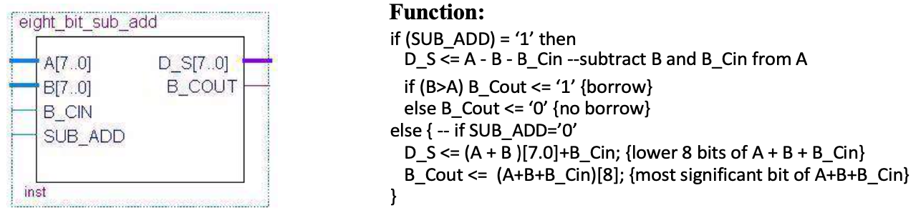

**Figure 1.** Eight-Bit Two’s Complement Subtractor/Adder Module

For the hierarchical schematic capture design entry method, we formulate a gate-level design from the bottom up, beginning by drafting the most elementary components to the most complex. The design is created at multiple levels to form a hierarchy of components, where more complex components are composed of less complex ones. We began with the 2 to 1 multiplexer as shown in Figure 2, saving it as a symbol and adding it to our library to be used in the successive level. Next, we move to designing the one-bit full subtractor/adder module as shown in Figure 3. The required three-input XOR gate was composed using two 2-input XOR gates. We compose the next four-bit subtractor/adder module using four of the one-bit subtractor/adder modules. This setup is displayed in Figure 4.

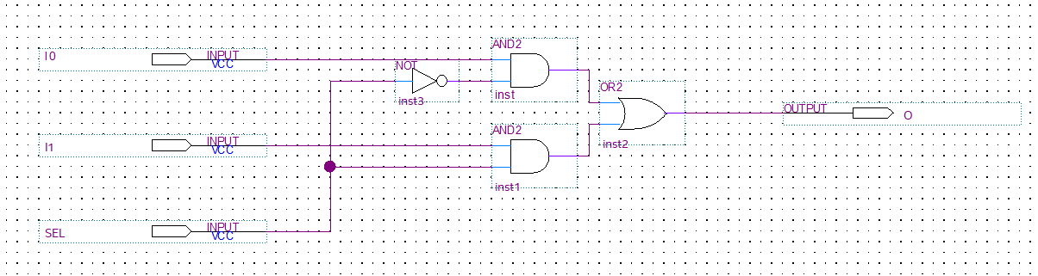

**Figure 2.** Representation of 2 to 1 Multiplexer (*mux2_1* module)

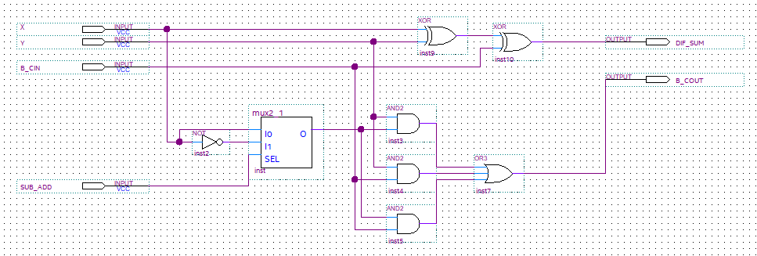

**Figure 3.** Representation of Subtractor/Adder (*fullSubAdd* module)

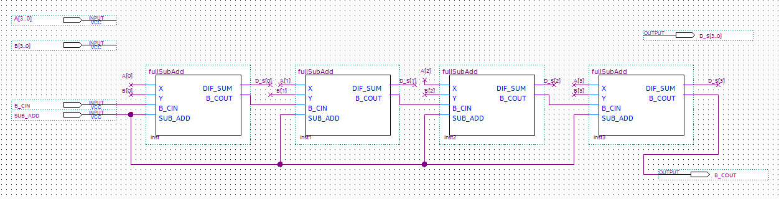

**Figure 4.** Representation of Four-bit Adder (*four_bit_sub_add* module)

Finally, the top-level module of the eight-bit subtractor/adder module is created using two of the four-bit adders as shown in Figure 5. It is important for proper compilation that this top-level module is specified correctly and matches the project name. After successful compilation, we also recorded the results, which will be discussed further later. For the demonstration, it was also necessary to assign the proper Cyclone IV pin number to the design I/O signal. We verified our design on the DE2-115 using the switches and LEDs to control and observe the eight-bit add/subtract operations.

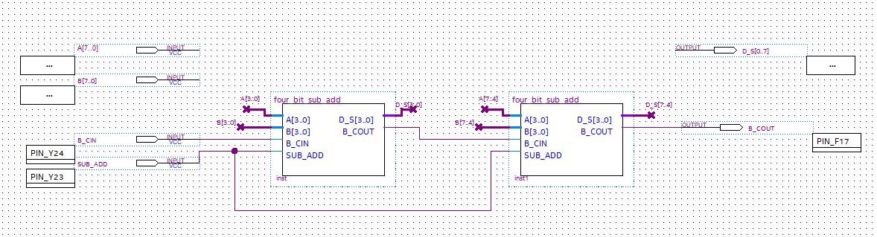

**Figure 5.** Top-Level Representation of Eight-bit Adder (*eight_bit_sub_add* module)

2.2 Assignment #2: Verilog HDL Entry and Implementation using Quartus Prime

For this assignment, we had to understand the basic syntax and structure of a Verilog HDL design in order to implement the structural and behavioral designs seen in Figure 6 and Figure 7. These designs would be functionally equivalent to each other in addition to the hierarchical schematic design from the previous assignment, resulting in a ripple two’s complement subtractor/adder. We ensured that these Verilog HDL designs compiled successfully and could be downloaded after proper pin assignment for demonstration on the DE2-115. The compilation results were also recorded and examined in a later section.

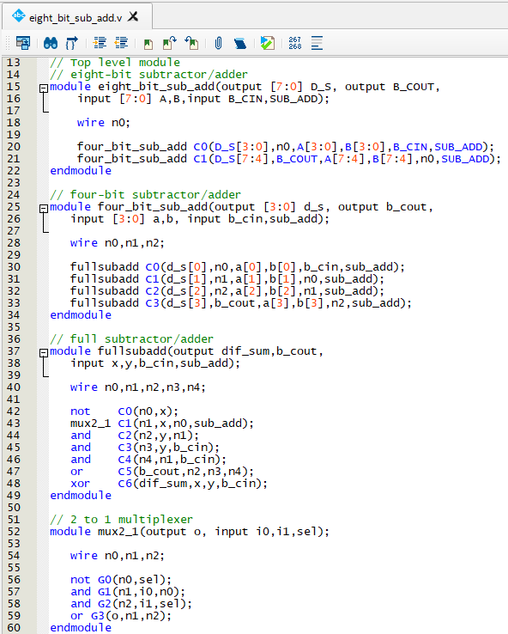

**Figure 6.** Structural Verilog HDL Design Implementation

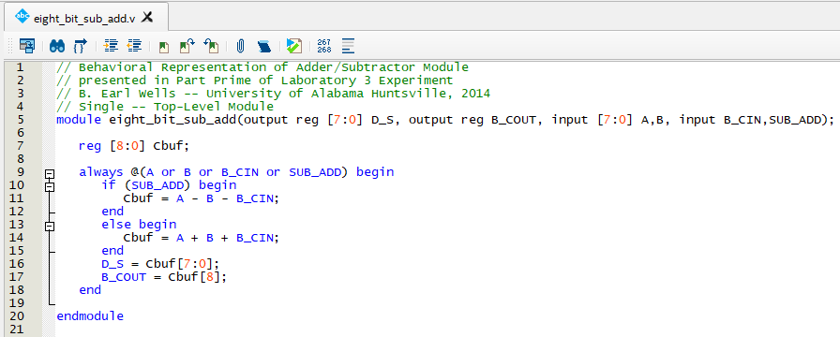

**Figure 7.** Behavioral Verilog HDL Design Implementation

In order to be able to verify our design, we had to understand basic binary addition and subtraction as well as two’s complement representation. We also needed to comprehend how the borrow/carry input and output functioned.

3. Demonstration

3.1 Assignment #1: Hierarchical Schematic Capture Design Entry and Implementation using Quartus Prime

To demonstrate our hierarchical schematic capture design of the eight-bit subtractor/adder, we had to compile and download to the Cyclone IV FPGA on our DE2-115. Assigning the correct pin numbers, which correspond to specific elements such as switches and LEDs, to the I/O signal in our design was key. These assignments as input in the pin planner can be viewed in Figure 8 below.

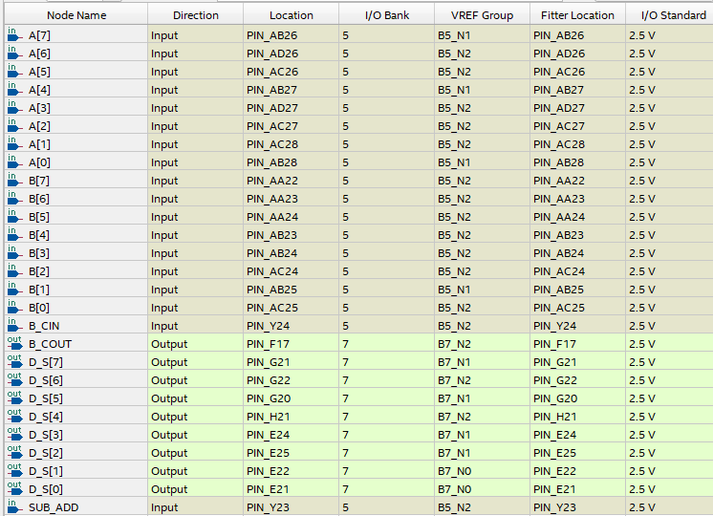

**Figure 8.** Cyclone IV Pin Locations to be used on DE2-115 Board

Switches 0-7 correspond to the LSB to MSB of the first 8-bit binary input while switches 8-15 correspond to the second 8-bit binary input. Switch 16 is B_CIN and switch 17 is SUB_ADD. LEDG0-7 represents the 8-bit binary output and LEDG8 is B_COUT.

We tested our design with 8 main test cases:

1. Add two unsigned 8-bit numbers that do not generate a carry on the B_COUT output.

SUB_ADD = 0; // Add mode

B_CIN = 0; // No Carry in

A = 17; // A = 8'b00010001

B = 2; // B = 8'b00000010

// D_S = A + B = 19 -- 8'b00010011

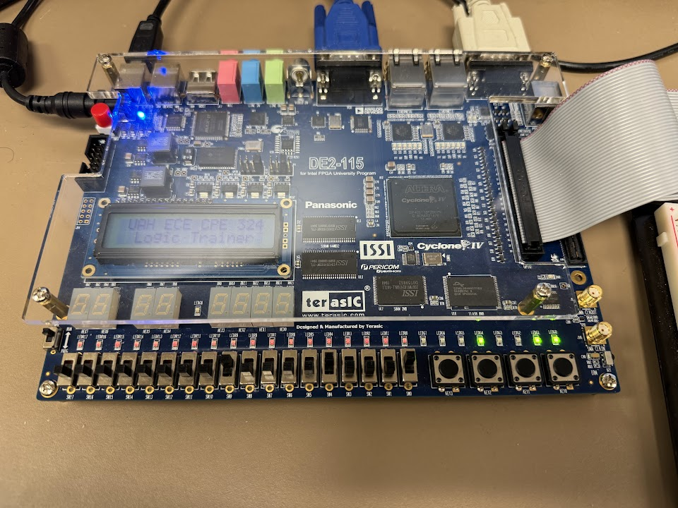

**Figure 9.** Result of adding two unsigned 8-bit numbers with no carry

1. Subtract two unsigned 8-bit numbers that do not generate a borrow on the B_COUT output.

SUB_ADD = 1; // Subtract mode

B_CIN = 0; // No Borrow in

A = 17; // A = 8'b00010001

B = 2; // B = 8'b00000010

// D_S = A - B = 15 -- 8'b00001111

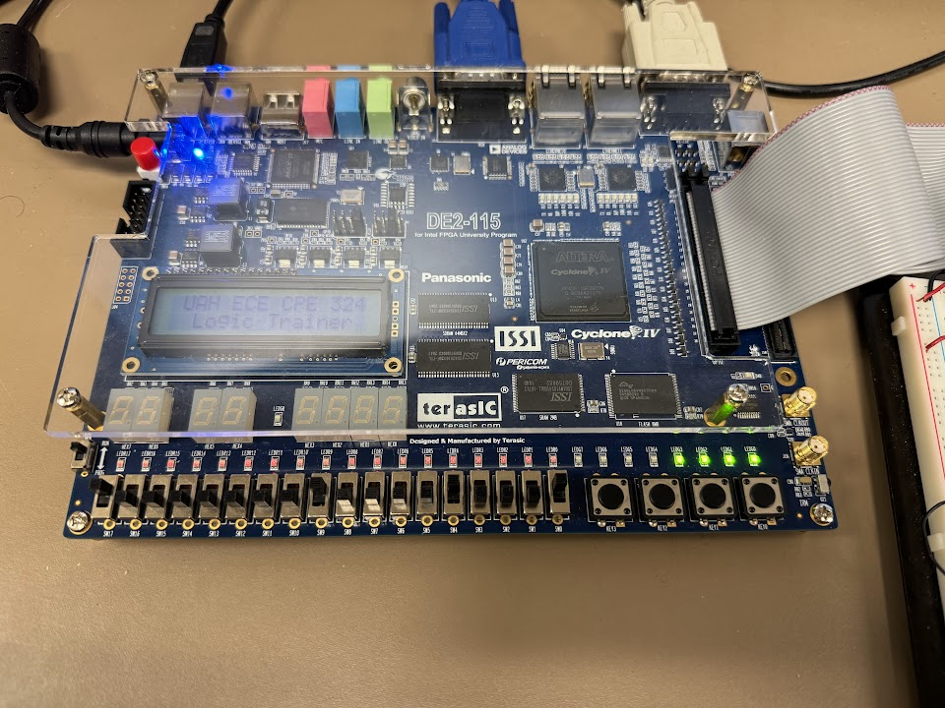

**Figure 10.** Result of subtracting two unsigned 8-bit numbers with no borrow

1. Add two unsigned 8-bit numbers in which there is a pending carry on the B_CIN input.

SUB_ADD = 0; // Add mode

B_CIN = 1; // Carry in

A = 17; // A = 8'b00010001

B = 2; // B = 8'b00000010

// D_S = A + B + B_CIN = 20 -- 8'b00010100

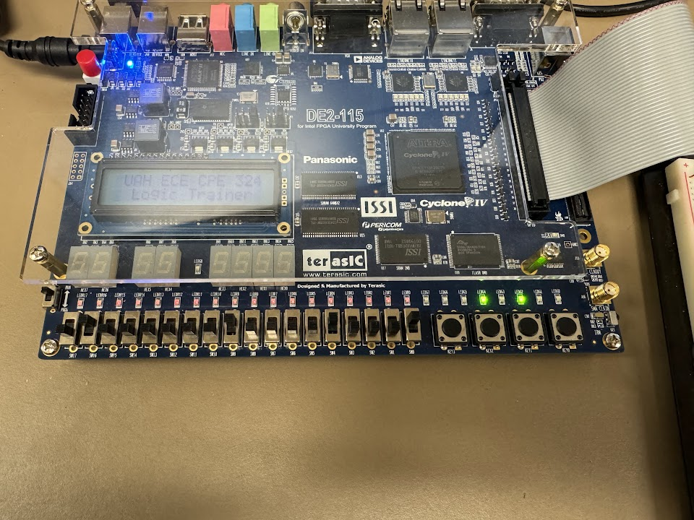

**Figure 11.** Result of adding two unsigned 8-bit numbers with pending carry

1. Subtract two unsigned 8-bit numbers when there is a pending borrow on the B_CIN input.

SUB_ADD = 1; // Subtract mode

B_CIN = 1; // Borrow in

A = 17; // A = 8'b00010001

B = 2; // B = 8'b00000010

// D_S = A - B - B_CIN = 14 -- 8'b00001110

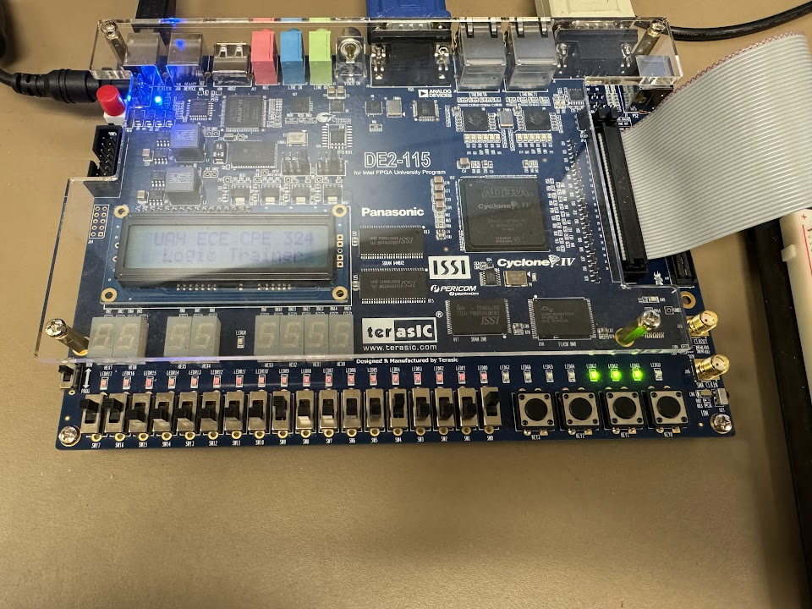

**Figure 12.** Result of subtracting two unsigned 8-bit numbers with pending borrow

1. Add two unsigned 8-bit numbers where an internal carry in propagates all the way from LSB to B_COUT output.

SUB_ADD = 0; // Add mode

B_CIN = 0; // No Carry in

A = 253; // A = 8'b11111101

B = 3; // B = 8'b00000011

// D_S = A + B = 256 -- 8'b00000000, B_COUT = 1

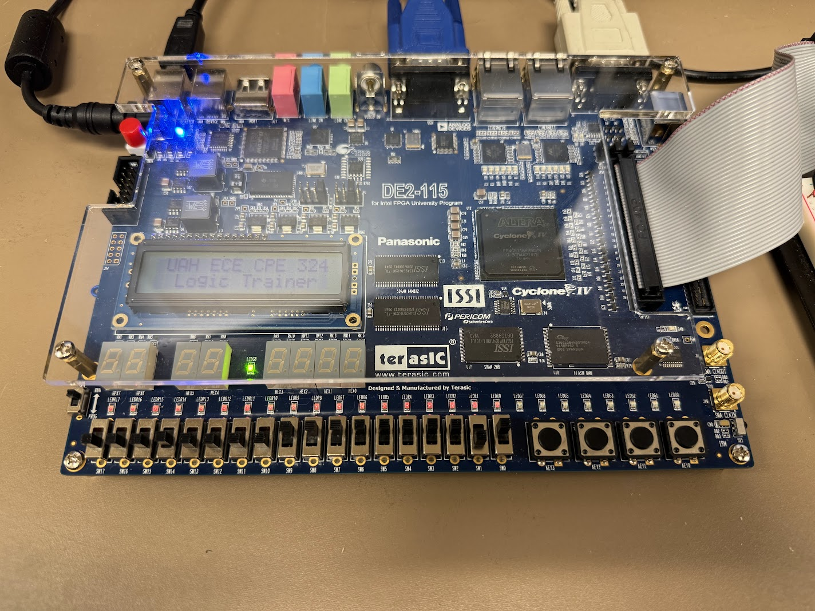

**Figure 13.** Result of adding two unsigned 8-bit numbers where carry propagates

1. Subtract two unsigned 8-bit numbers where a borrow in propagates all the way from LSB and generates a borrow request on the B_COUT output.

SUB_ADD = 1; // Subtract mode

B_CIN = 1; // Borrow in

A = 2; // A = 8'b00000010

B = 3; // B = 8'b00000011

// D_S = A - B = -1 -- 8'b11111111, B_COUT = 1

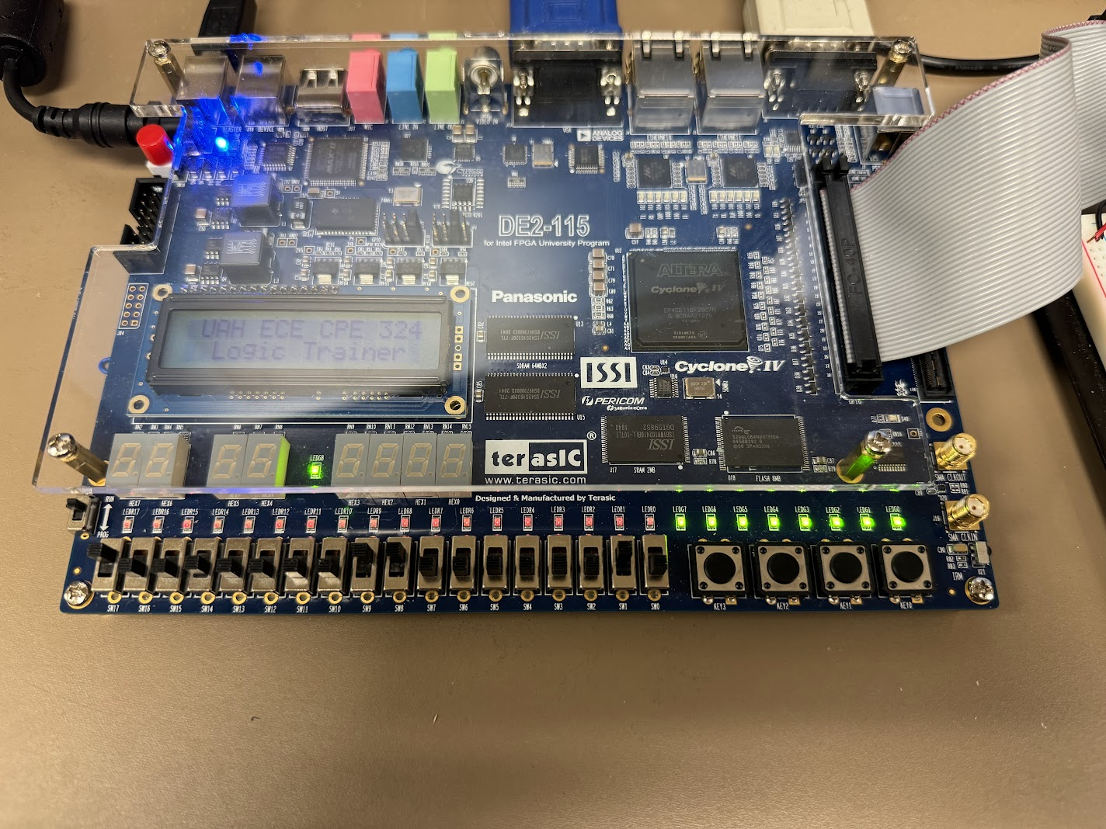

**Figure 14.** Result of subtracting two unsigned 8-bit numbers where borrow propagates

1. Add two numbers that causes an overflow into the carry bit.

SUB_ADD = 0; // Add mode

B_CIN = 0; // No Carry in

A = 128; // A = 8'b10000000

B = 128; // B = 8'b10000000

// D_S = A + B = 256 -- 8'b00000000, B_COUT = 1

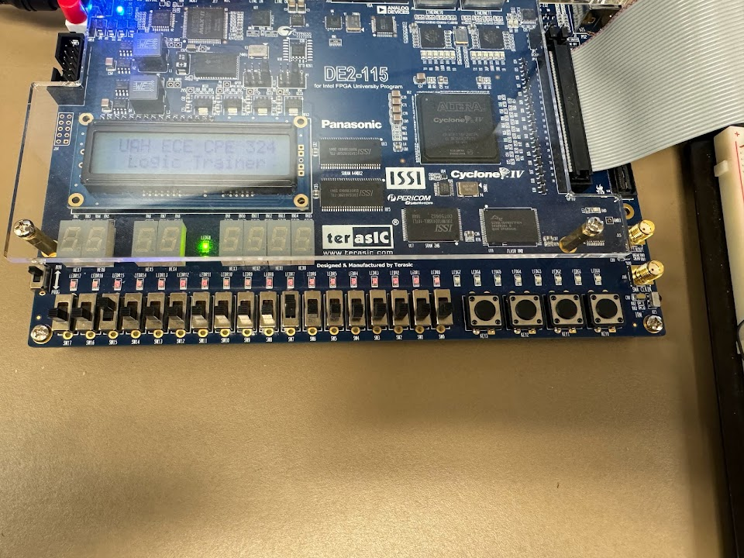

**Figure 15.** Result of adding two numbers that cause an overflow into the carry bit

1. Assuming that the numbers are represented in 2’s complement and the MSB is interpreted as the sign bit, subtract a larger positive 8-bit signed number from a smaller 8-bit signed positive number thereby generating a negative result.

SUB_ADD = 1; // Subtract mode

B_CIN = 0; // No Borrow in

A = 1; // A = 8'b00000001

B = 3; // B = 8'b00000011

// D_S = A - B = -2 -- 8'b11111110, B_COUT = 1

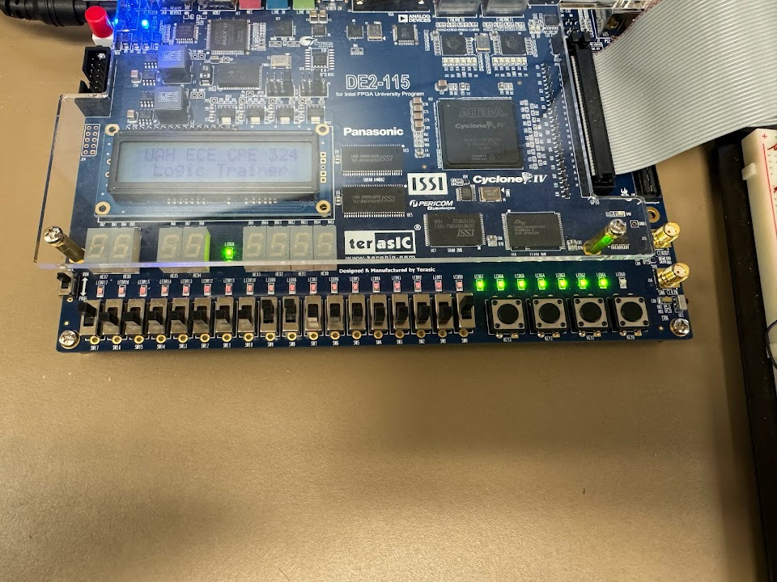

**Figure 16.** Result of subtracting a larger positive 8-bit signed number from a smaller one

3.2 Assignment #2: Verilog HDL Entry and Implementation using Quartus Prime

For both our structural and behavioral Verilog HDL implementations, we wanted to verify their functionality with the same set of test cases but different values from the hierarchical schematic design. For each Verilog HDL representation, we tested our design with 8 main test cases:

1. Add two unsigned 8-bit numbers that do not generate a carry on the B_COUT output.

SUB_ADD = 0; // Add mode

B_CIN = 0; // No Carry in

A = 73; // A = 8'b01001001

B = 2; // B = 8'b00000010

// D_S = A + B = 75 -- 8'b01001011

1. Subtract two unsigned 8-bit numbers that do not generate a borrow on the B_COUT output.

SUB_ADD = 1; // Subtract mode

B_CIN = 0; // No Borrow in

A = 33; // A = 8'b00100001

B = 1; // B = 8'b00000001

// D_S = A - B = 32 -- 8'b00100000

1. Add two unsigned 8-bit numbers in which there is a pending carry on the B_CIN input.

SUB_ADD = 0; // Add mode

B_CIN = 1; // Carry in

A = 73; // A = 8'b01001001

B = 2; // B = 8'b00000010

// D_S = A + B +B_CIN = 76 -- 8'b01001100

1. Subtract two unsigned 8-bit numbers when there is a pending borrow on the B_CIN input.

SUB_ADD = 1; // Subtract mode

B_CIN = 1; // Borrow in

A = 33; // A = 8'b00100001

B = 1; // B = 8'b00000001

// D_S = A - B - B_CIN = 31 -- 8'b00011111

1. Add two unsigned 8-bit numbers where an internal carry in propagates all the way from LSB to B_COUT output.

SUB_ADD = 0; // Add mode

B_CIN = 0; // No Carry in

A = 251; // A = 8'b11111011

B = 5; // B = 8'b00000101

// D_S = A + B = 256 -- 8'b00000000, B_COUT = 1

1. Subtract two unsigned 8-bit numbers where a borrow in propagates all the way from LSB and generates a borrow request on the B_COUT output.

SUB_ADD = 1; // Subtract mode

B_CIN = 0; // No Borrow in

A = 0 // A = 8'b00000000

B = 1; // B = 8'b00000001

// D_S = A - B = -1 -- 8'b11111111, B_COUT = 1

1. Add two numbers that causes an overflow into the carry bit.

SUB_ADD = 0; // Add mode

B_CIN = 0; // No Carry in

A = 129; // A = 8'b10000001

B = 130; // B = 8'b10000010

// D_S = A + B = 259 -- 8'b00000011, B_COUT = 1

1. Assuming that the numbers are represented in 2’s complement and the MSB is interpreted as the sign bit, subtract a larger positive 8-bit signed number from a smaller 8-bit signed positive number thereby generating a negative result.

SUB_ADD = 1; // Subtract mode

B_CIN = 0; // No Borrow in

A = 2; // A = 8'b00000010

B = 16; // B = 8'b00010000

// D_S = A - B = -14 -- 8'b11110010, B_COUT = 1

We observed the LEDs on the DE2-115 light up as expected for each test case in the demonstration, confirming the same functionality for every design of the eight-bit two’s complement adder/subtractor module.

4. Experimental Results

4.1 Assignment #1: Hierarchical Schematic Capture Design Entry and Implementation using Quartus Prime

In addition to observing the full functionality of our eight-bit adder on our DE2-115 board, we also recorded the statistics of the compilation window for each representation. The compilation window for the hierarchical schematic design is shown below in Figure 17. As we can see, 16 total logic elements were used and 27 total pins. The logic elements are counted including all levels of components in the design hierarchy.

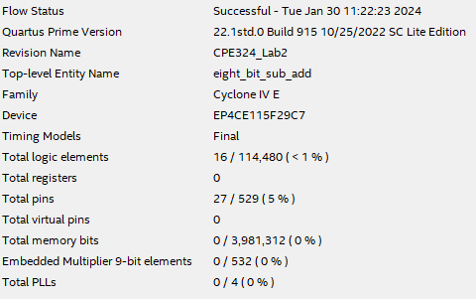

**Figure 17.** Compilation Window for Schematic Design

4.2 Assignment #2: Verilog HDL Entry and Implementation using Quartus Prime

For the Verilog HDL designs, the compilation window for the structural implementation can be seen in Figure 18 and for the behavioral representation in Figure 19. The behavioral design was the only one that showed any differences with 18 total logic elements while the structural design utilized 16. Both implementations used 27 pins, which is expected since all of the designs required the same amount of interfaced hardware to verify functionality on the Cyclone IV E.

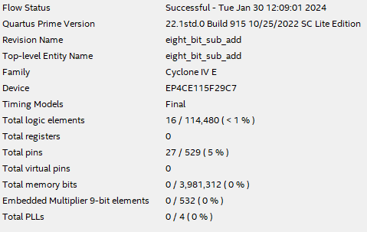

**Figure 18.** Compilation Window for Structural Design

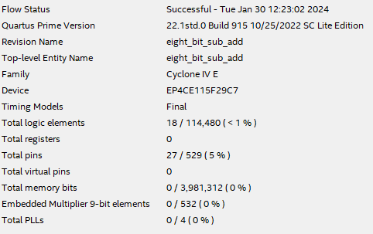

**Figure 19.** Compilation Window for Behavioral Design

Lab Questions

1. For your three versions of this design, what kind of compilation errors did you encounter? How did you correct the errors and how did you determine which were important and which ones could be ignored?

We encountered a couple compilation errors during the development of the three versions of this design, which were all relatively easily solvable or could be ignored in our case.

Firstly, we had a warning that the number of parallel processors had not been specified. This was ignored since the design still functioned properly and we did not need parallel computing for performance over sequential. Another warning stated that no clocks were defined in the design. To my knowledge, these implementations were not synchronous so a clock definition was not necessary.

There was also an error when formatting the hierarchical schematics when elements were not properly connected, this was fixed by ensuring everything was connected where it should be. Another error stated that a module cannot be declared more than once, this was easily resolved by removing the unintentional duplicate module declaration.

1. How does hierarchical schematic capture and hierarchical structural Verilog HDL design techniques help one manage the complexity of the design process?

Hierarchical schematic capture and hierarchical structural Verilog HDL design techniques help manage the complexity of the design process by allowing modularity and reusability of modules. Both methods facilitate the recycling of certain components and allow for an organization that is relatively easy to understand and visualize the structure of the modules. This also benefits abstraction, making it easier to focus on each individual level or module more effectively.

1. Do you think the stimulus you used is good enough to verify the full functionality of your design? Why or why not? Would this stimulus be good enough to be used to automatically test the design for manufacturing defects? Why or why not?

The provided stimulus was crucial to verifying the functionality of our designs, and I do think that the stimulus used was sufficient in our case, although there are potentially other boundary and special cases that could be tested to improve thoroughness and reliability of testing. We did test the use of the carry/borrow in and out with positive and negative values, verifying the two’s complement representation worked in addition to utilizing both operations. But, we could go even further and test max/min values and observe how our design handles rapid operation requests. Overflow conditions with signed arithmetic could also be examined for further testing. Thus, I am not sure that this stimulus would be good enough to be used to automatically test the design for manufacturing defects.

1. Were there any differences between the amount of FPGA resources that were used for each design? If so, how did they differ? If not, do you believe that the designs are implemented in the same manner by the Quartus Prime synthesis tool?

The only difference between the amount of FPGA resources that were used for each design was that the behavioral Verilog design utilized 18 logic elements while the schematic and structural designs only used 16. This could imply that the designs are implemented differently by the Quartus Prime synthesis tool. The behavioral implementation was written with a higher level of abstraction, which could require more logic resources in exchange for conciseness. The optimization may have been processed differently resulting in variation in the resource utilization. In terms of functionality though, all the designs were the same and each had benefits and drawbacks.

1. Describe the design trade-offs associated with the structural and behavioral Verilog versions in terms of ease of design entry and the ability to control the low-level attributes of the design (such as what type of subtractor/adder is created).

There are a few key design trade-offs associated with the structural and behavioral Verilog versions. The structural design has more control over the low-level attributes of the design, such as what type of adder or subtractor is created, in comparison to the behavioral design. This is due to the modularity and hierarchical structure still present and reminiscent of the schematic representation. Whereas behavioral Verilog has greater ease of design entry and a higher level of abstraction, resulting in a more compact but potentially less clear design. Depending on project requirements and preference, one method could be a better fit than the other.

5. Conclusion

In this lab, we gained valuable exposure to design and capture techniques using the Quartus software tool. We were able to create an 8-bit two’s complement adder/subtractor using three methods: schematic, behavioral Verilog, and structural Verilog. The pin planner was used to connect to the Cyclone IV E on the DE2-115, so that we could test and verify our designs using the switch and LED hardware. Multiple inputs were tested to get a solid sense of the functionality and determine if our observed outputs matched what we were expecting. Through the design process, we developed an idea of the advantages and disadvantages to each type of representation, specifically the concepts of modularity and ease of design. Referring to the compilation window, we were able to record and compare the FPGA resources used by each design implementation, furthering our understanding of the differences between them.